CHATGPT

Devansh Sanjaykumar Brahmbhatt

**Introduction:**

ChatGPT is an artificial intelligence chatbot. It was created by Open AI and released in November 2022. It’s a ground-breaking technology because it’s been taught to understand what people mean when they ask questions. Many users awe of its capacity to deliver responses of human quality, which gives rise to the idea that it might eventually have the ability to change how people interact with computers and alter how information is retrieved.

ChatGPT was developed on top of the Open AI large language models (LLMs) from the GPT-3.5 and GPT-4 families. It has been fine-tuned (a transfer learning method) using both supervised and reinforcement learning strategies. The history of language models, which has expanded and improved since the 1950s, is what led to the development of ChatGPT. Chats, machine translation, and speech recognition are just a few of the applications that have used language models, which are created to comprehend human language and produce natural and fluent text.

Using a wide variety of texts from books, articles, and websites as training data, chatbot I can comprehend and produce text on a variety of subjects. To train ChatGPT on what people anticipate when they ask questions, Reinforcement learning with human feedback was used train ChatGPT. This method of training the LLM is innovative since it goes beyond only training it to predict the next word. ChatGPT was specially taught to comprehend the human purpose behind a query and offer useful, accurate and safe replies. This distinguishes ChatGPT from a straightforward chatbot.

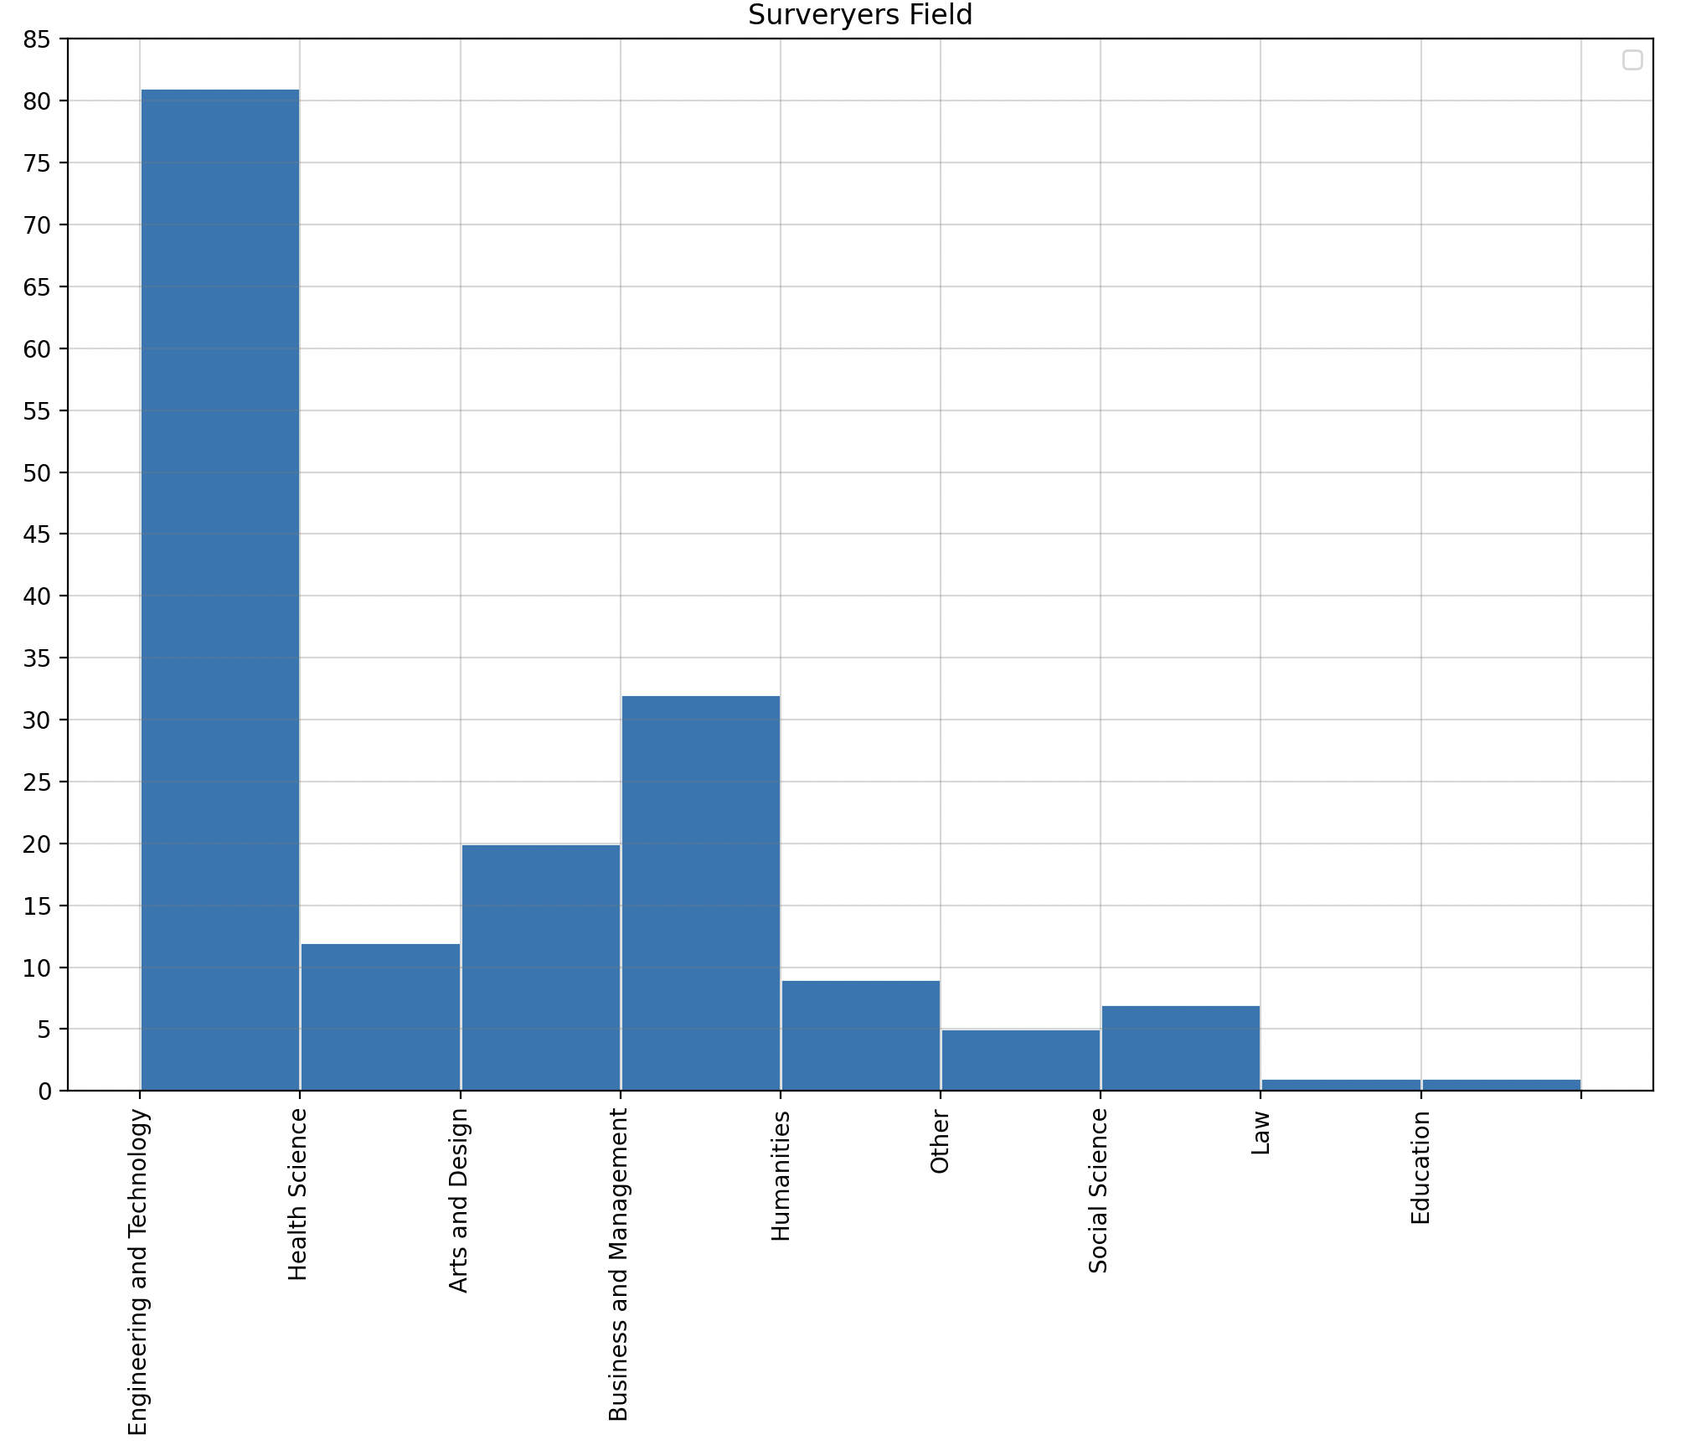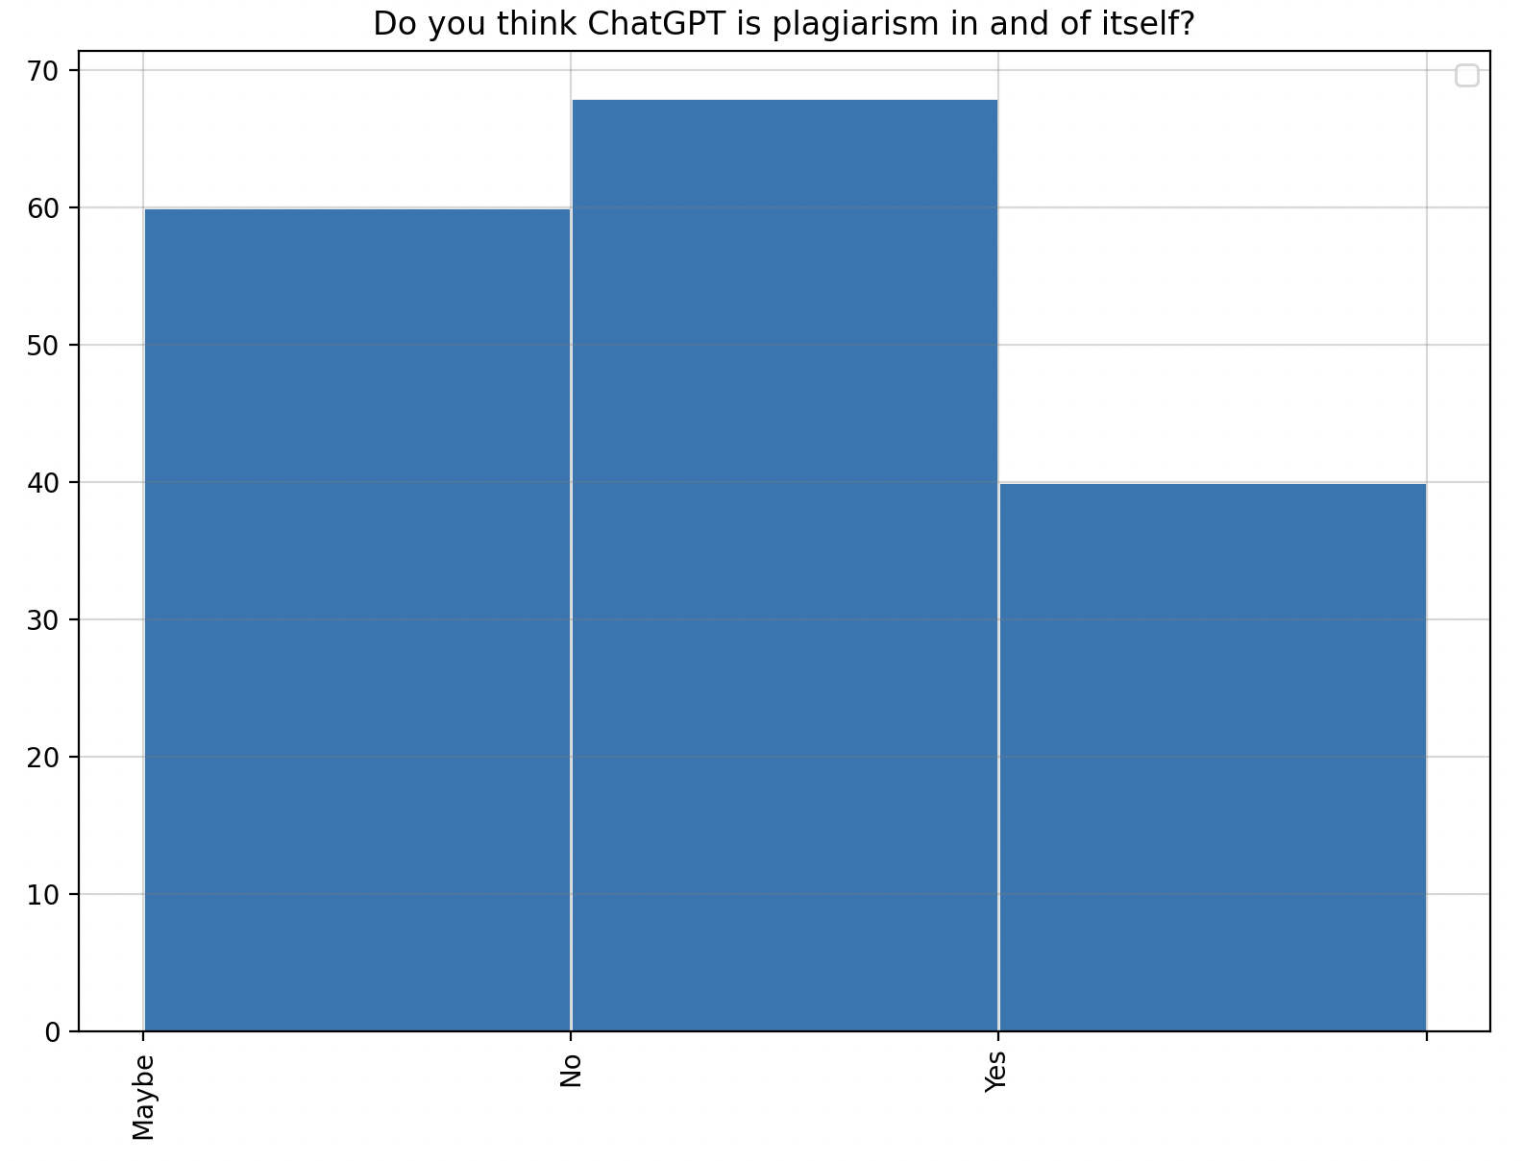

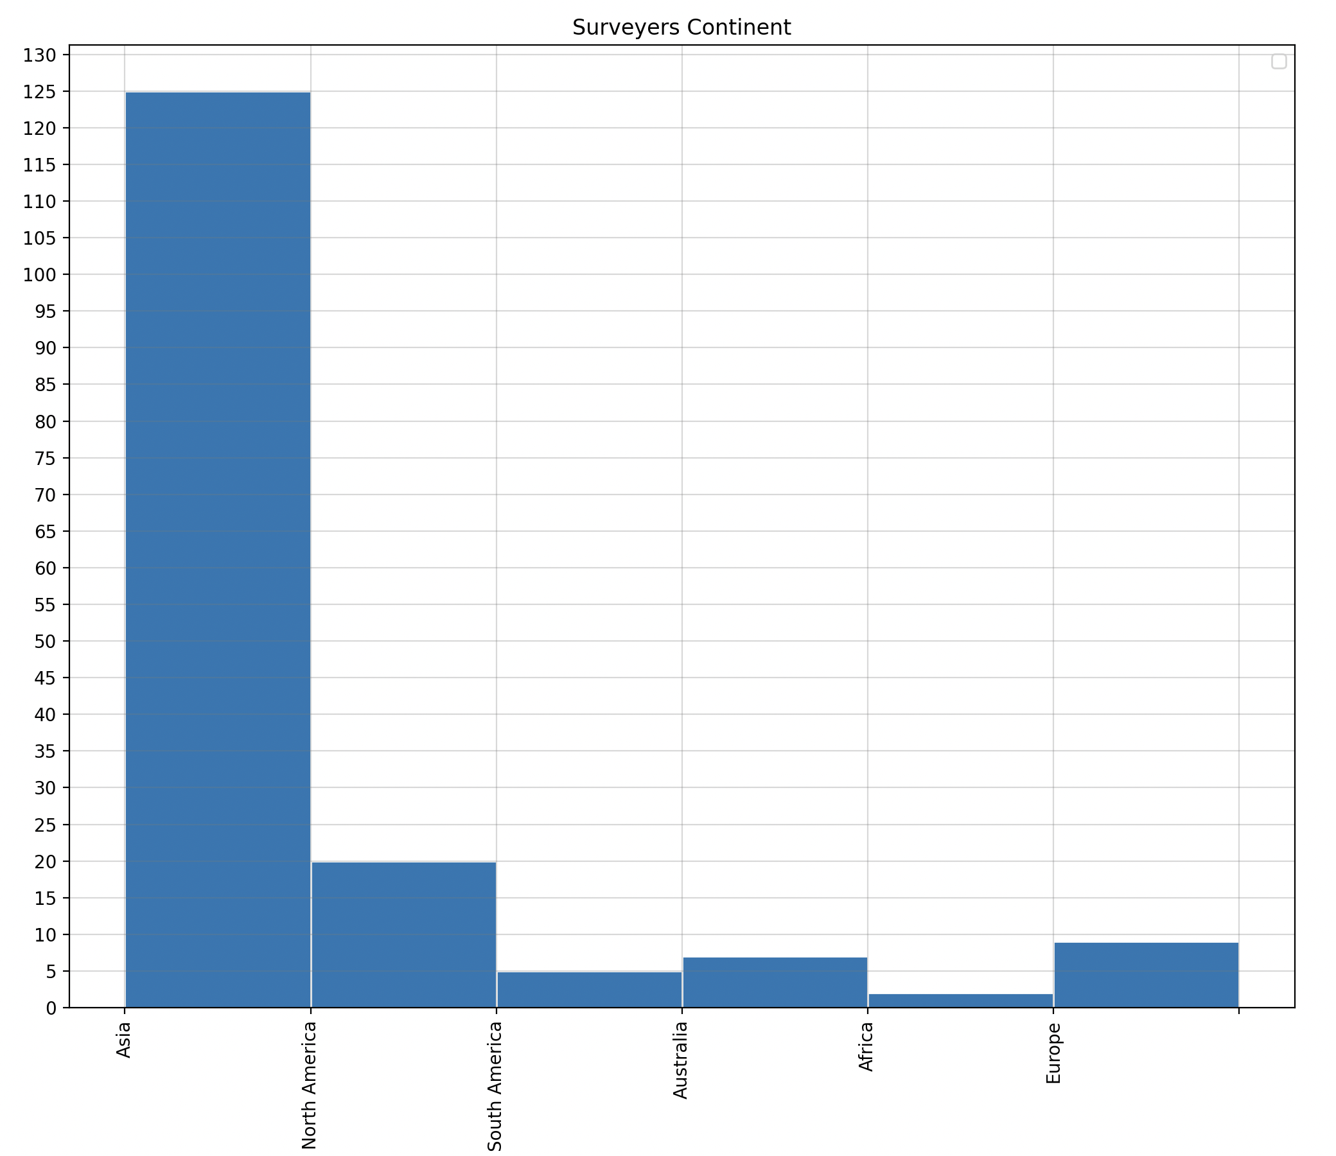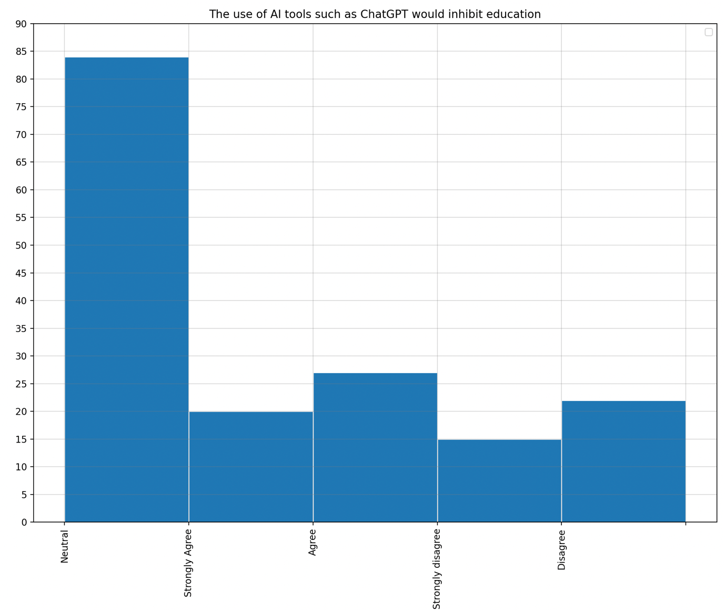

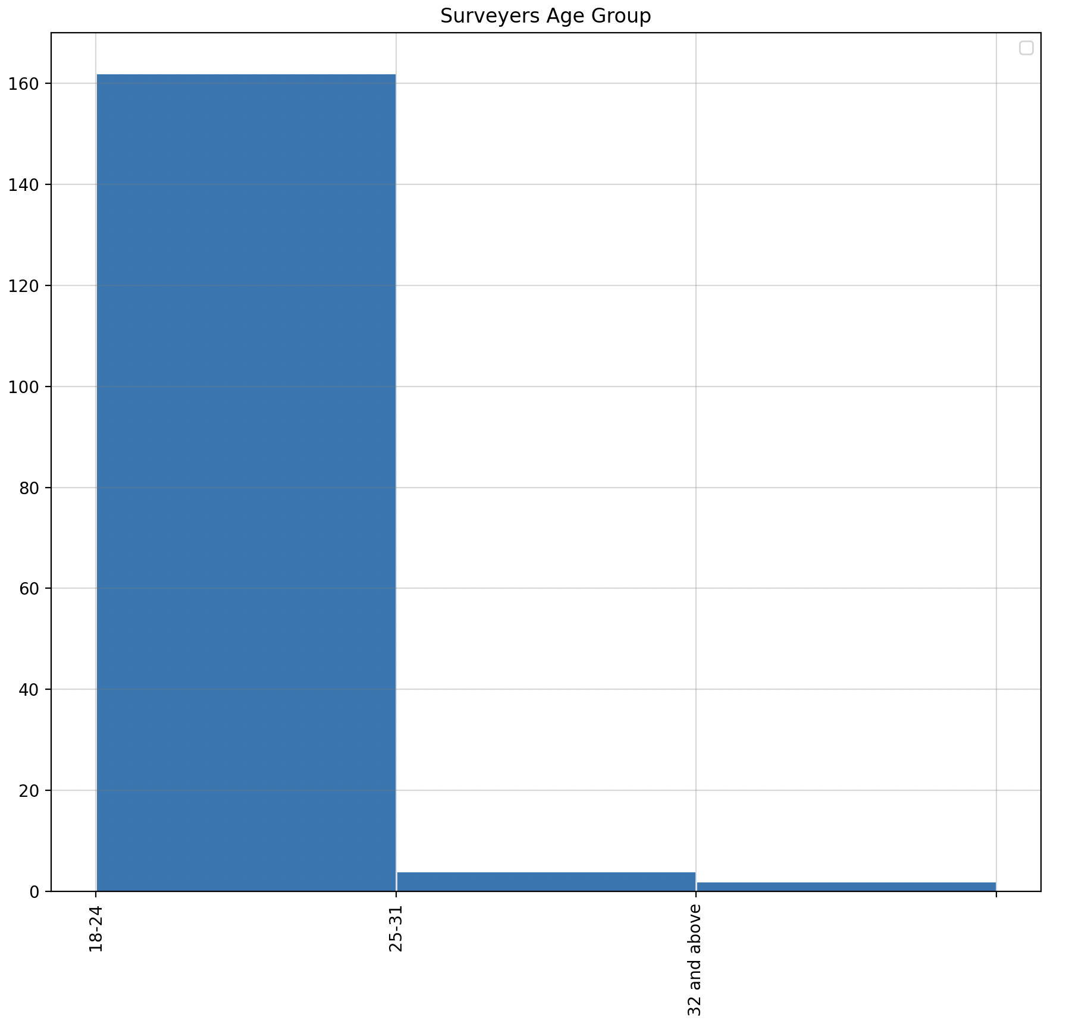

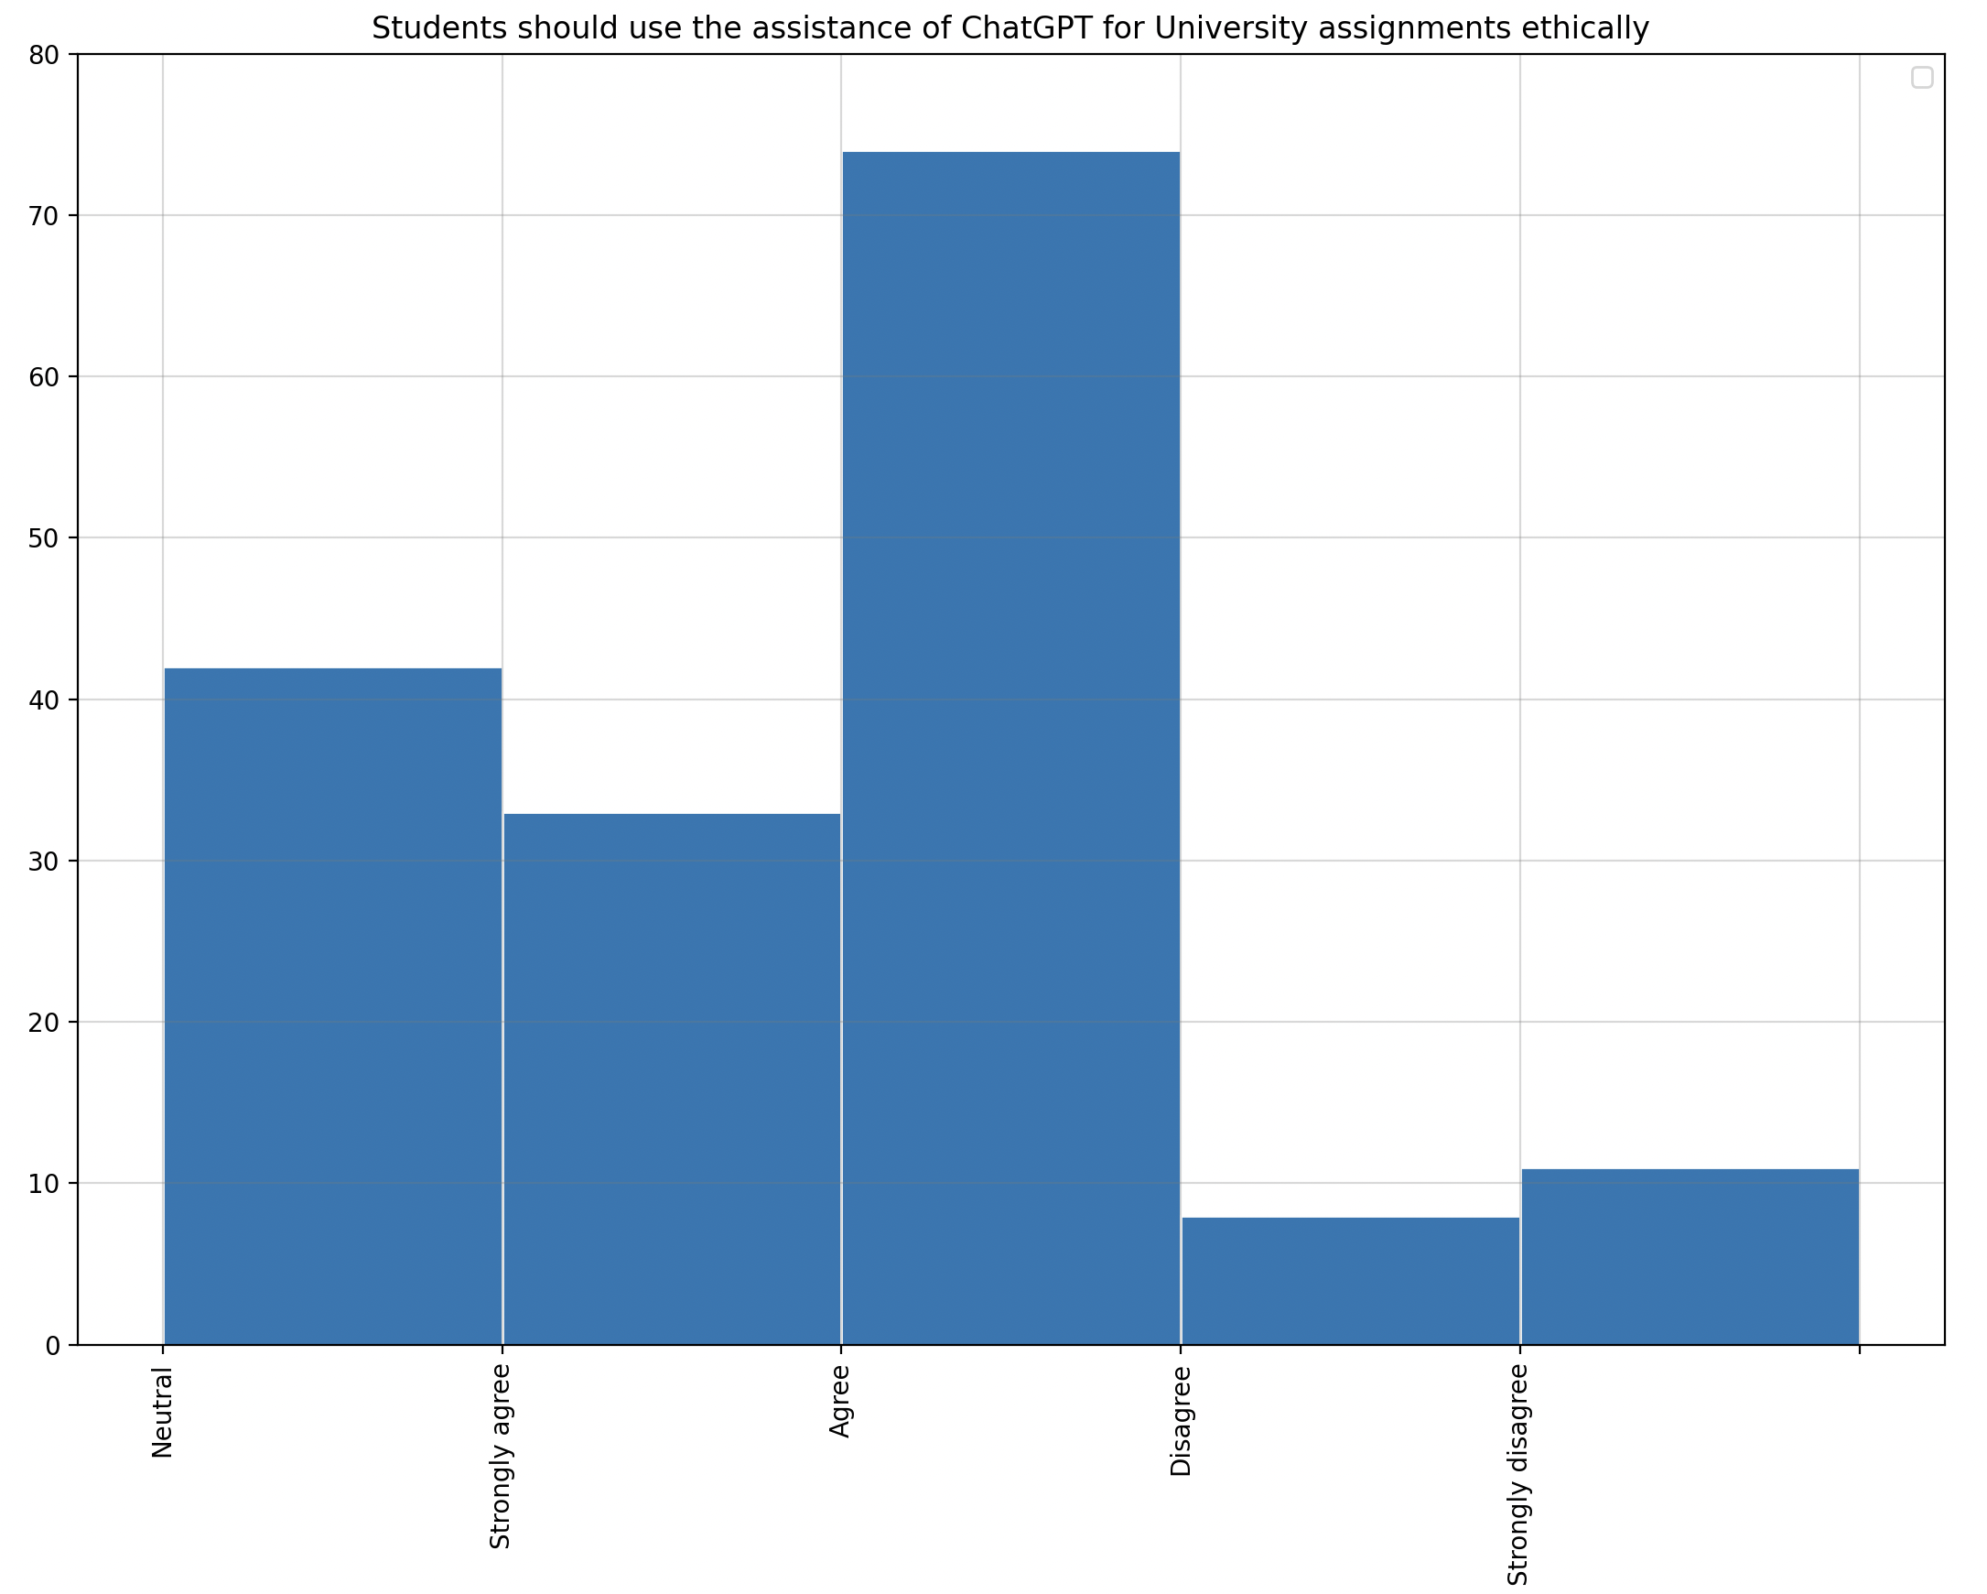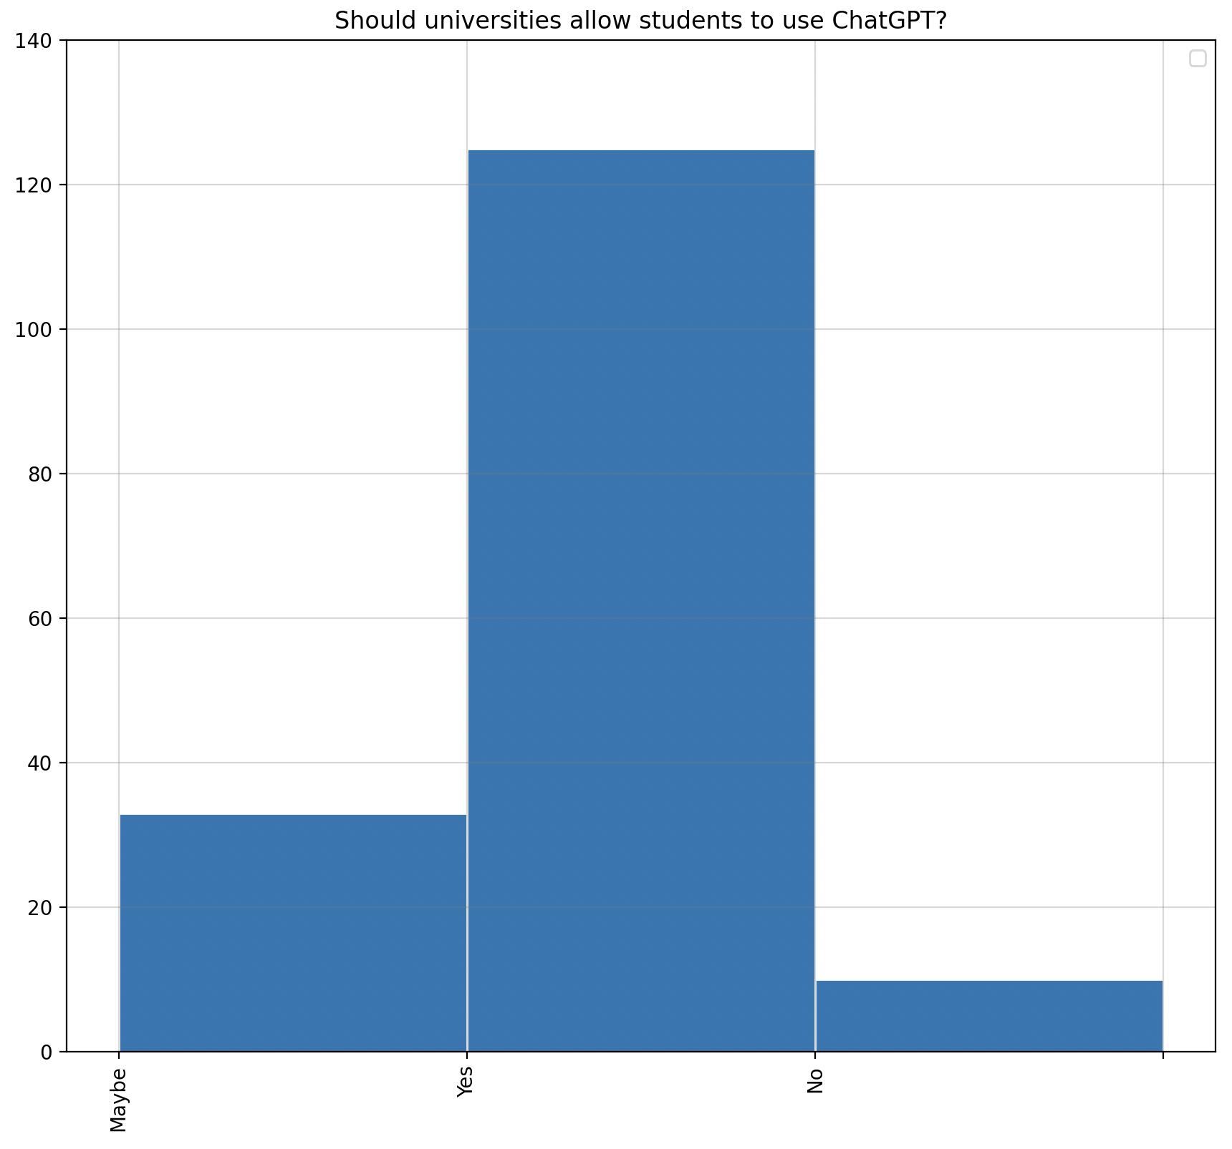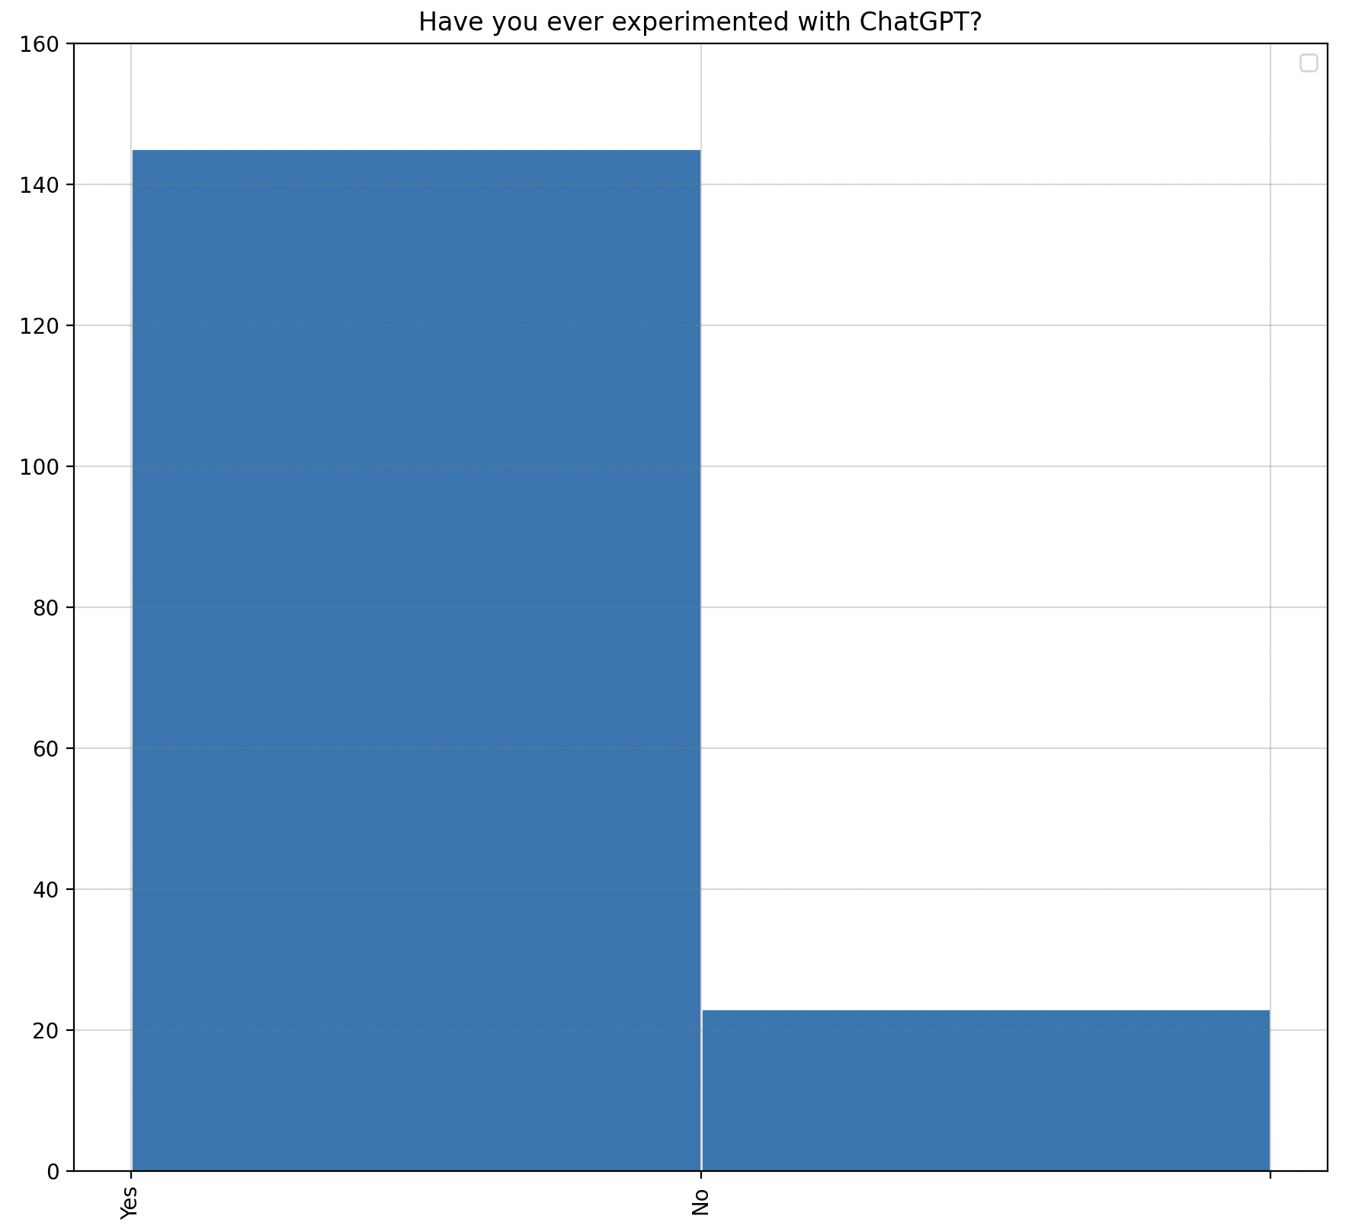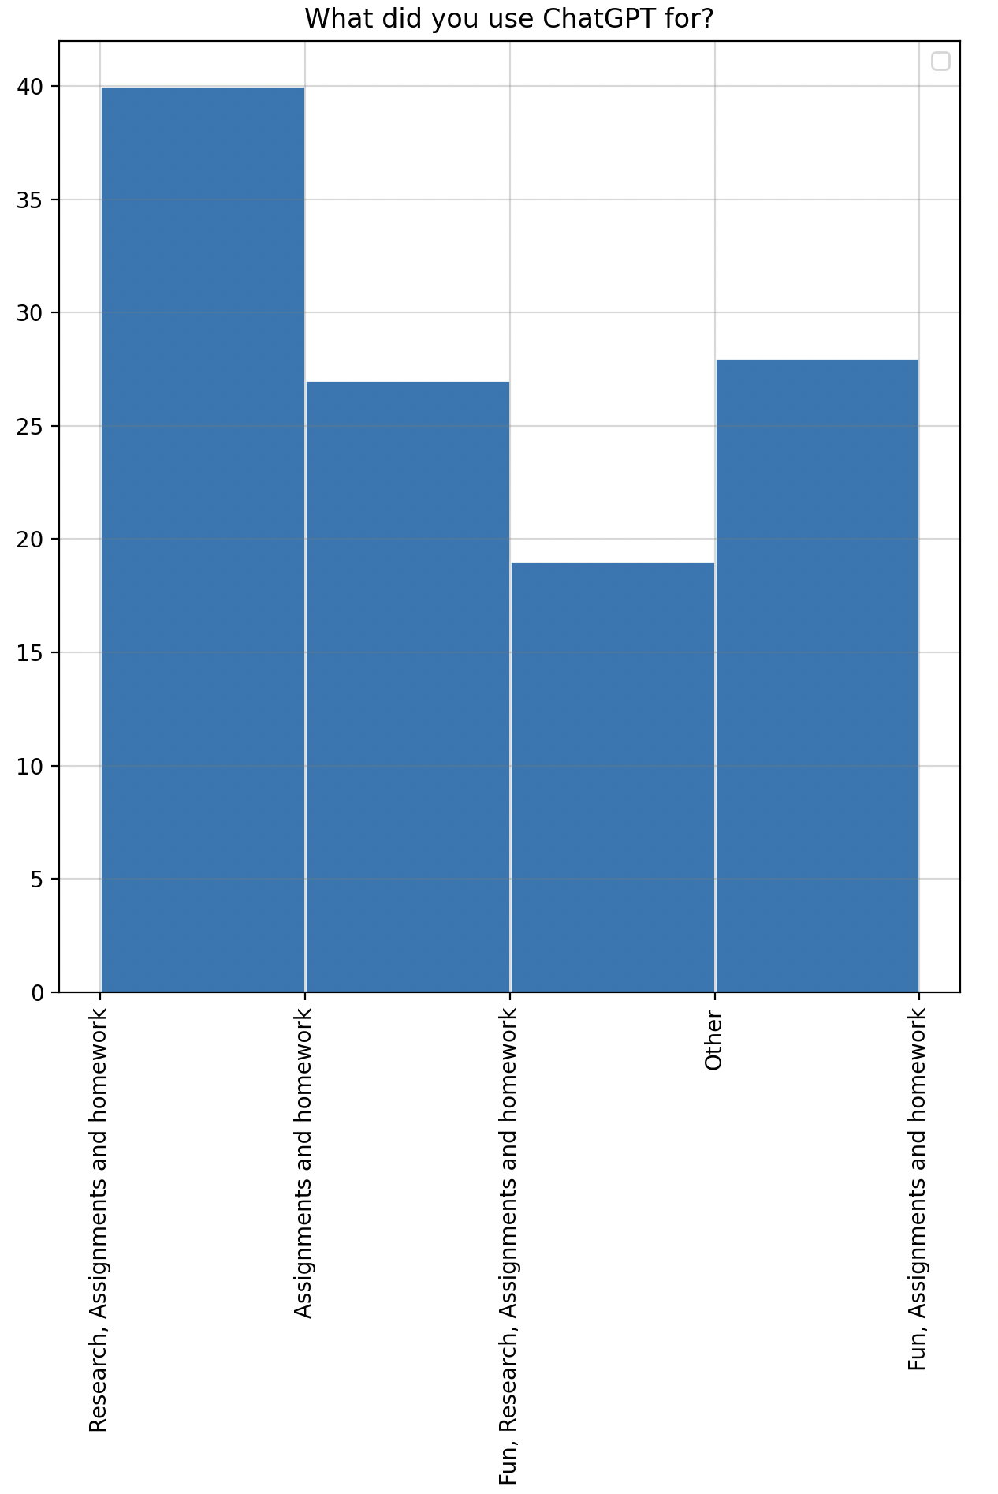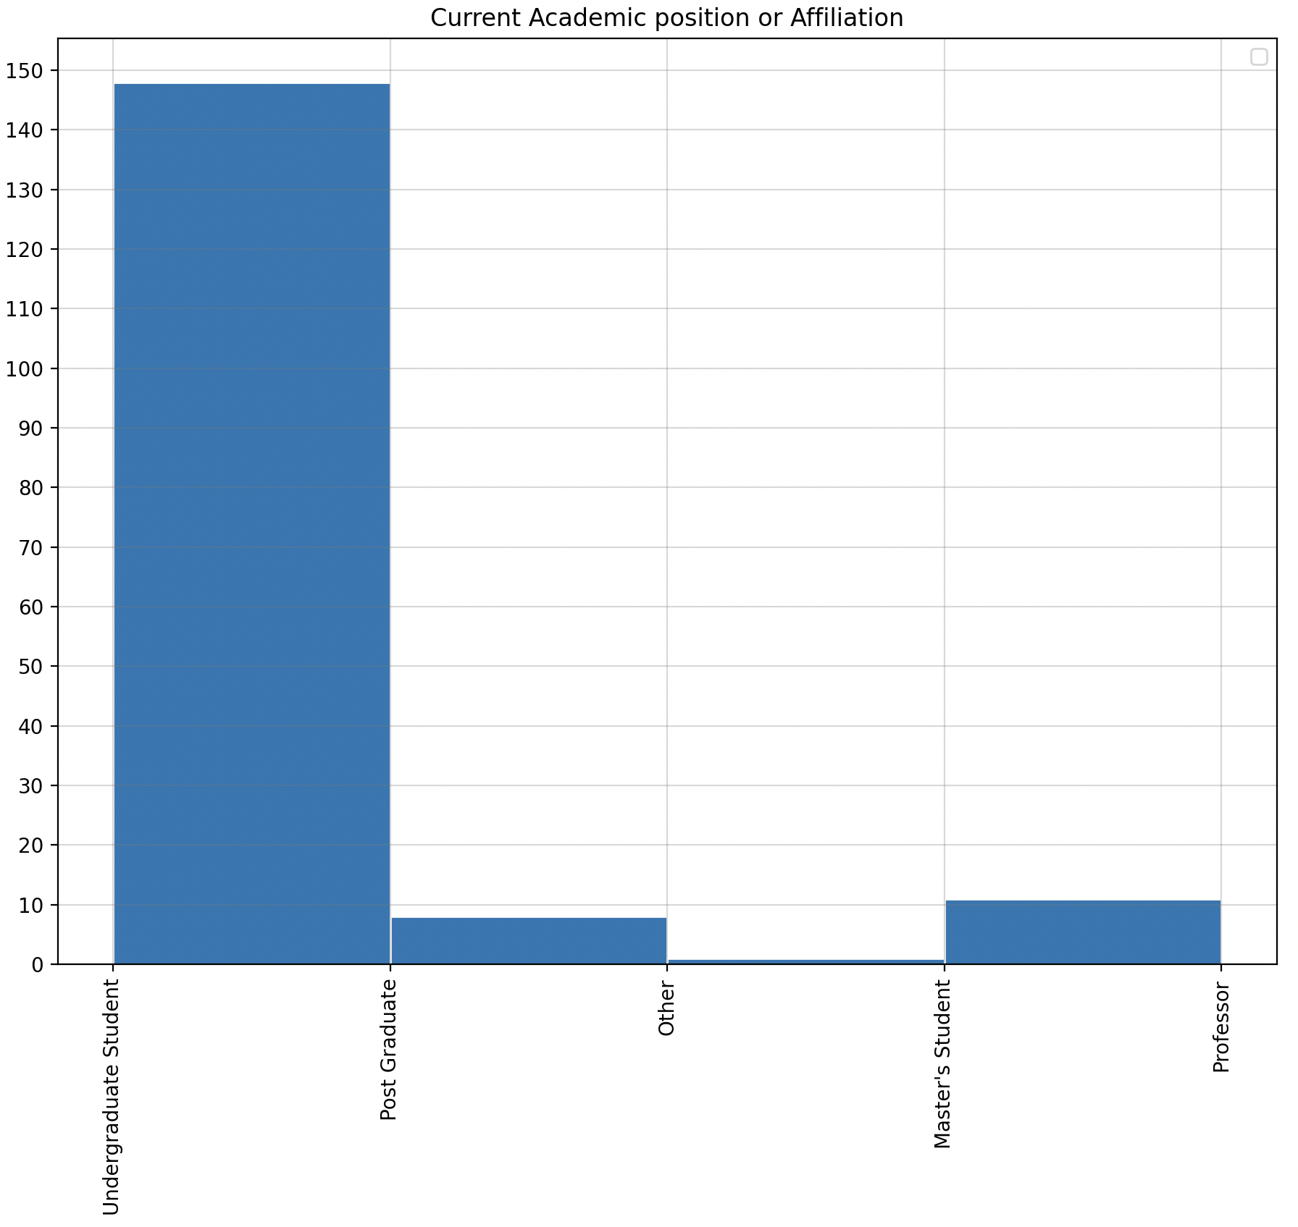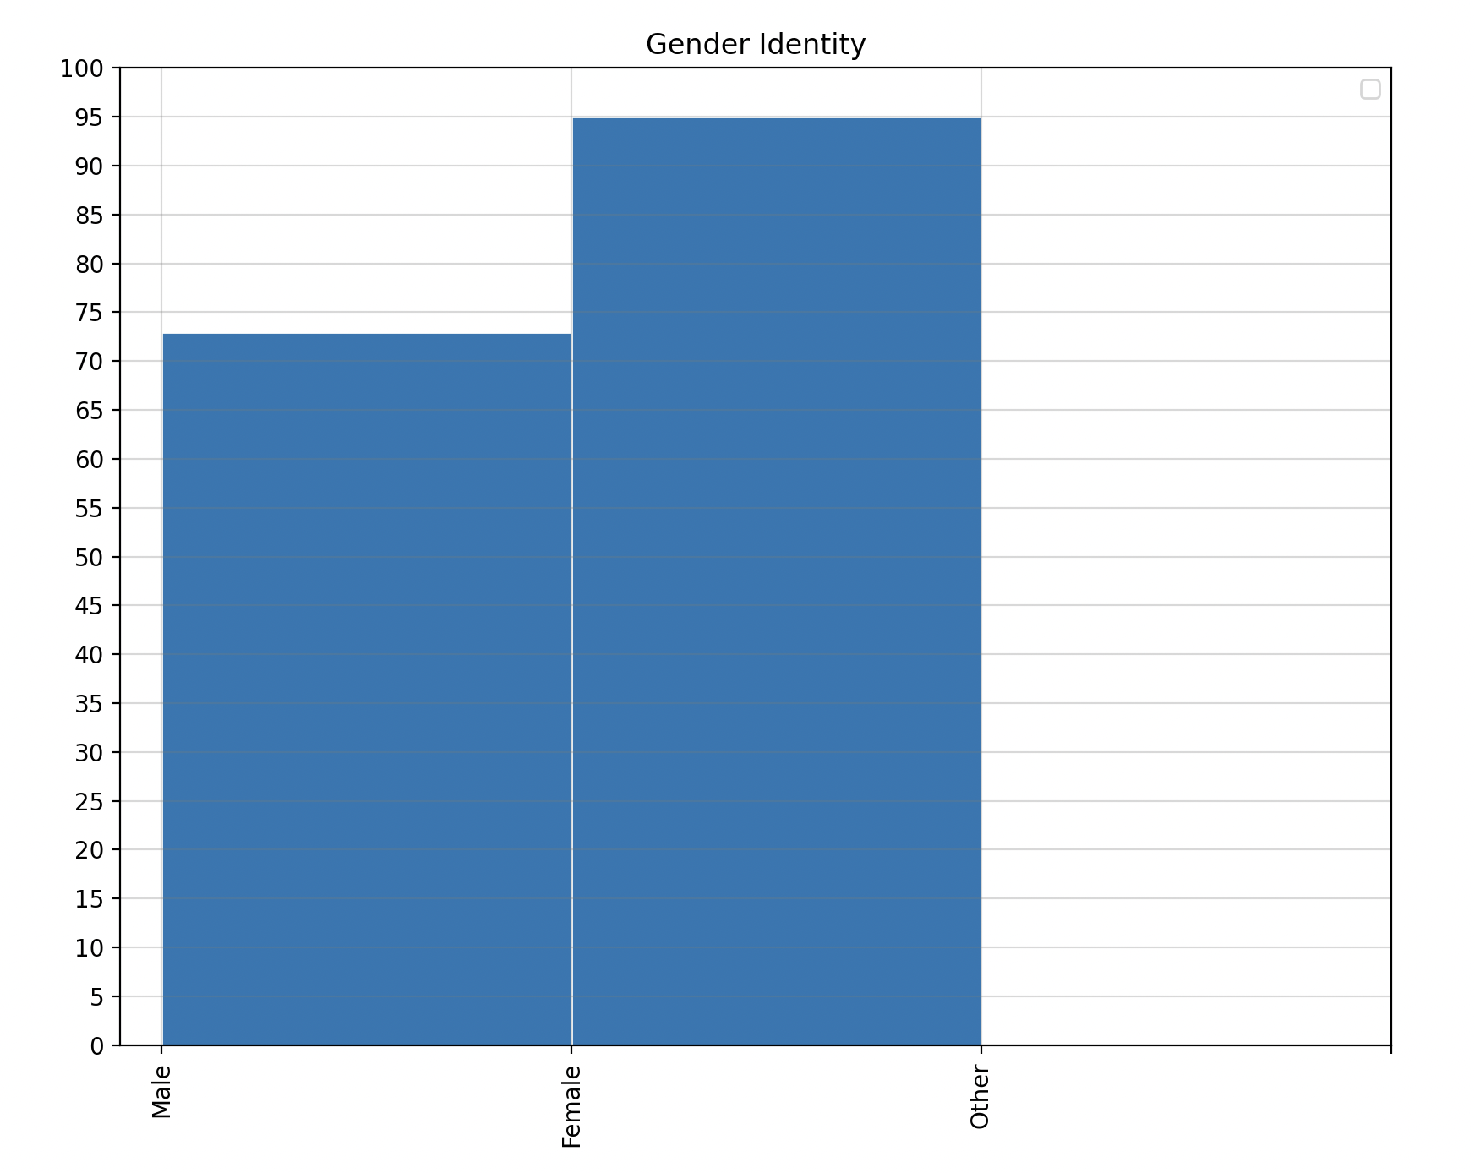

**Finding from the Data we collected:**

The pie charts and histograms shown above were created using data from our survey. And, as the graphs show, the majority of ChatGPT users are between the ages of 18 and 24, with many pursuing careers in engineering and technology. Furthermore, we can see that the females have reached a unanimous decision. Furthermore, they believe that the use of ChatGPT is beneficial to academia, that there is no plagiarism, and that universities and other educational institutions should allow students to use ChatGPT for assistance with assignments and projects. The Asian audience has also expressed strong support.

Benefits and Limitations of ChatGPT:

**>>> Benefits of ChatGPT:**

Although chatbots have been of interest for decades, the most of them are still quite rudimentary and can simply reply to an attempt to remedy the problems of disgruntled customers. Yet, with hatGPT's ability to continue a conversation over several questions and generate programming code, the area of NLP is entering a new phase. Because it is a machine-learning model, ChatGPT can assist with a wide range of NLP-related operations. Because it was trained using a large collection of text, it can interpret and respond to a wide range of enquiries and requests in a human-like manner. It may offer various advantages they are mentioned below :

1) Improved efficiency and precision in NLP operations.

2) Quick and accurate replies to a variety of inquiries.

3) Help with a variety of professions involving natural language comprehension and production.

4) ChatGPT may modify the complexity of the discussion or questions based on the student's level of comprehension. As a result, the learning process may become more personalised and effective.

5) Each degree of knowledge or comprehension in ChatGPT can alter the complexities of the argument.

6) It can help students and instructors save time by responding fast to queries.

**>>> Limitations Of ChatGPT:**

1. Lack of human interaction :

While ChatGPT can carry on a discussion and deliver information, it cannot provide personalized feedback or engage in live chat with students. This may limit the learning process and make it difficult for students to fully comprehend a topic or to seek clarification.

1. Reliance on technology:

Because ChatGPT is reliant on technology to function, it may not be always available or encounter technical difficulties. This can be annoying for children who are trying to learn and may hinder their development.

3)Context limitation:

While ChatGPT is intelligent, it can misinterpret context, resulting in incorrect output.

4Lack of Critical Thinking:

Critical thinking is an important skill to teach students, but if the answers are always at their fingertips, they will not have to think for themselves.

5)Lack of original thought:

ChatGPT may generate entire essays. The act of having someone else do something for you is the act of having someone else do something for you. Plagiarism checks are catching up because this is one of the most serious problems with ChatGPT.

**Future of ChatGPT:**

ChatGPT is an artificial intelligence with the potential to revolutionise education. The industry is still unsure whether things will improve or worsen. Although it can be beneficial to educators and students, it can also make it easy to steal ideas and lead to an over-reliance on technology. As educators and students learn more about chatGPT, the good should outweigh the bad, and AI will help improve education day by day.

**In conclusion**, ChatGPT may be a helpful resource for students looking to sharpen their language abilities or learn more about a specific subject. But you shouldn’t rely only on this instrument for education; you should also take into account its limits. The ideal approach to assure a well-rounded education is to combine ChatGPT with other tools and techniques, like a tutor or teacher.

The Future is full of opportunities and ChatGPT is leading the charge, But we must also remember to treat it carefully and consider the potential downsides, ensuring that we use this technology in a way that enhances students’ learning experience and supports the development of their critical thinking and problem-solving skills. As we continue to explore the endless potential of AI in education, the future is looking brighter than ever before, and we can’t wait where this journey will take us next.

# References

A. (2023, March 27). *Chat GPT limitations &#8211; What it can&#8217;t do?* MLYearning. https://www.mlyearning.org/chat-gpt-limitations/

C. (2022, December 26). *The Pros and Cons of Students Using ChatGPT*. Cyberwise. https://www.cyberwise.org/post/the-pros-and-cons-of-students-using-chatgpt#:~:text=Lack%20of%20human%20interaction%3A%20While,time%20conversation%20with%20a%20student

*ChatGPT: AI and the Future of Education | New Jersey City University*. (n.d.). https://www.njcu.edu/academics/schools-colleges/deborah-cannon-partridge-wolfe-college-education/departments/educational-technology/chatgpt-ai-and-future-education

ChatGPT, K. M. A. (2022, December 9). *How ChatGPT Could Transform Higher Education*. Social Science Space. https://www.socialsciencespace.com/2022/12/how-chatgpt-could-transform-higher-education/

Karageorgakis, T. (2023, January 17). *ChatGPT in school: How AI is changing the Future of Education*. Educraft. https://educraft.tech/chatgpt-in-school-how-ai-is-changing-the-future-of-education/

Marr, B. (2023, March 3). *The Top 10 Limitations Of ChatGPT*. Forbes. https://www.forbes.com/sites/bernardmarr/2023/03/03/the-top-10-limitations-of-chatgpt/?sh=45ad2eb68f35

Rushda, S. (2023, March 8). *ChatGPT explained: What are its benefits and limitations?* HGS. https://hgs.cx/blog/chatgpt-explained-what-are-its-benefits-and-limitations/

**Appendix**

Thankyou.